Assignment 3

1.Write java Program for Consider a scenario, Bank is a class that provides functionality to get rate of interest. But, rate of interest varies according to banks. For example, SBI, ICICI and AXIS banks could provide 8%, 7% and 9% rate of interest.(Method Overriding)

CODE:

class Bank {

double getRateOfInterest() {

return 0.0;

}

}

class SBI extends Bank {

@Override

double getRateOfInterest() {

return 8.0;

}

}

class ICICI extends Bank {

@Override

double getRateOfInterest() {

return 7.0;

}

}

class AXIS extends Bank {

@Override

double getRateOfInterest() {

return 9.0;

}

}

public class Main {

public static void main(String[] args) {

Bank sbi = new SBI();

Bank icici = new ICICI();

Bank axis = new AXIS();

System.out.println("SBI Rate of Interest: " + sbi.getRateOfInterest() + "%");

System.out.println("ICICI Rate of Interest: " + icici.getRateOfInterest() + "%");

System.out.println("AXIS Rate of Interest: " + axis.getRateOfInterest() + "%");

}

}

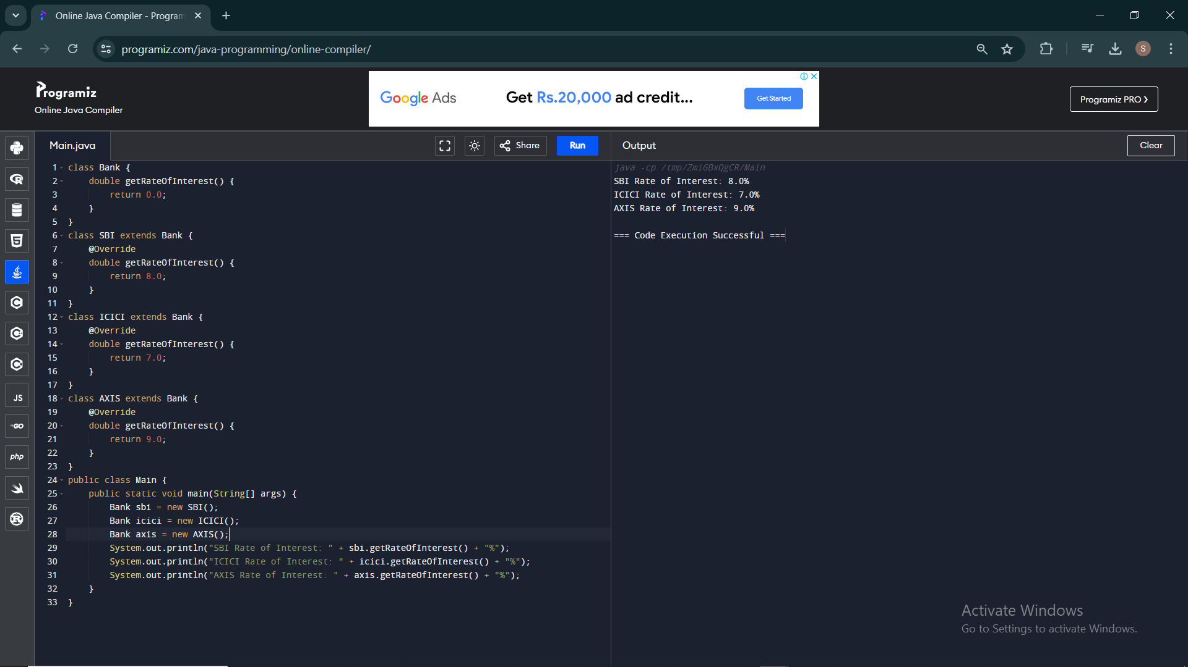

2. Develop a JAVA code to display the balance. Include the following members:

• Design a class to represent a bank account.

• Data Members: Name of the depositor, Account number, Type of account(Savings/Current), Balance amount in the account(Minimum balance is Rs.500.00)

• Methods:

1. To read account number, Depositor name, Type of account.

2. To deposit an amount (Deposited amount should be added with it)

3. To withdraw an amount after checking balance(Minimum balance must be Rs.500.00

Note : Assume that balance amount = 10000

Test Cases

1. 100, Raja, S, 8000

2. Raja, 100, S, 9000

3. 101, Rani, S, 12000

4. 102, Ragu, W, 8000

5. 103, Ravi, C, 10000

CODE:

import java.util.Scanner;

class BankAccount {

private String depositorName;

private int accountNumber;

private String accountType;

private double balanceAmount;

private static final double MINIMUM_BALANCE = 500.00;

public BankAccount(String depositorName, int accountNumber, String accountType, double balanceAmount) {

this.depositorName = depositorName;

this.accountNumber = accountNumber;

this.accountType = accountType;

this.balanceAmount = balanceAmount;

}

public void readAccountDetails() {

Scanner scanner = new Scanner(System.in);

System.out.println("Enter Account Number: ");

accountNumber = scanner.nextInt();

scanner.nextLine();

System.out.println("Enter Depositor Name: ");

depositorName = scanner.nextLine();

System.out.println("Enter Account Type (Savings/Current): ");

accountType = scanner.nextLine();

}

public void deposit(double amount) {

balanceAmount += amount;

System.out.println("Amount Deposited. New Balance: " + balanceAmount);

}

public void withdraw(double amount) {

if (balanceAmount - amount >= MINIMUM_BALANCE) {

balanceAmount -= amount;

System.out.println("Amount Withdrawn. New Balance: " + balanceAmount);

} else {

System.out.println("Insufficient balance. Minimum balance of Rs.500.00 must be maintained.");

}

}

public void displayBalance() {

System.out.println("Account Balance: " + balanceAmount);

}

public void displayAccountDetails() {

System.out.println("Account Number: " + accountNumber);

System.out.println("Depositor Name: " + depositorName);

System.out.println("Account Type: " + accountType);

System.out.println("Balance Amount: " + balanceAmount);

}

public static void main(String[] args) {

BankAccount account1 = new BankAccount("SANJAY", 100, "Savings", 5000);

BankAccount account2 = new BankAccount("RAJ", 101, "Savings", 2000);

BankAccount account3 = new BankAccount("RAJU", 102, "Current", 8000);

BankAccount account4 = new BankAccount("DON", 103, "Current", 70000);

account1.displayAccountDetails();

account2.displayAccountDetails();

account3.displayAccountDetails();

account4.displayAccountDetails();

account1.deposit(1000);

account1.withdraw(1000);

account1.displayBalance();

account2.deposit(2000);

account2.withdraw(1500);

account2.displayBalance();

account3.deposit(500);

account3.withdraw(9000);

account3.displayBalance();

account4.deposit(5000);

account4.withdraw(4000);

account4.displayBalance();

}

}

